MIDTOWNERS SUNSHINE OF THE WEEK ► August 3rd, 2007
Birthday of Rtn. Devendra Nath Gongal on August 5th
Birthday of Sunila Sthapit , spouse of PP Ajaya on August 8th

SPEAKER OF THE WEEK ► NO SPEAKER
THEME | CLUB ASSEMBLY
This is the first Club Assembly of Rotary Year 2007-08. The new board will present the plans for the year.

UPCOMING SPEAKERS ► PREVIEW
DATE | SPEAKER | THEME
Aug 10th | Mr. Rajeev Adhikari  Sr. Consultant, Total Management Service | Donor driven Development
Aug 17th | Ms. Trishna Gurung  Communications and Marketing Manager, WWF Nepal | Global Climate Change
Aug 24th | Dr. Pramod B. Shrestha  Professor, IOE | Cambodia: Images of a country (Past, Present and Future)

THE MID-TOWN CLUB ► NEWS
CONDOLENCE
The Mid-Town family is saddened by the demise of the father of yet another active member. Rtn. Devendra Nath Gongal’s father passed away on. We all pray for his soul, and our hearts are with the bereaved family.
LAST WEEK’S SPEAKER
Caroline Jacoby, MPH, a Senior Program Officer for the Johns Hopkins Bloomberg School of Public Health/ Center for Communication Programs (JHU/CCP) enlightened us on the state o a glimpse of maternal and neo-natal health in Nepal, and gave us a glimpse of what has been done in disseminating information to reduce the mortality rates. She has been in Nepal with JHU/CCP under the DFID-funded Support to Safe Motherhood Program for the last 18 months and her office is located in the National Health Education, Information and Communication Center (NHEICC).
Handing out Check
President Walter handed out a check of $300 to Dr. Suman Thapa of Til Ganga Eye Hospital as part of our club contribution in the Yag Laser project.
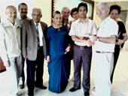
President Walter and other Mid-Towners with Dr. Suman Thapa

Rotaract News
The Rotaracts have had a busy schedule. Here are some news on what they have been doing:
- Soft Opening of the 10+2 Education at Jana Sewa Higher Secondary School in Paanga through the joint efforts of a family : Rotarians/Rotaracts and the school Family on July 31st. The Rotaracts of Kathmandu Mid-Town handed over Rs. 22,000 that was contributed by Rotaracts and their well-wishers. President Walter contributed Rs. 1000.
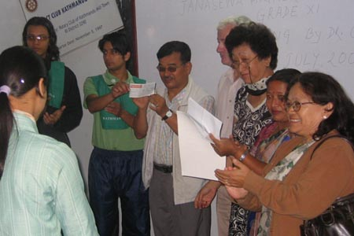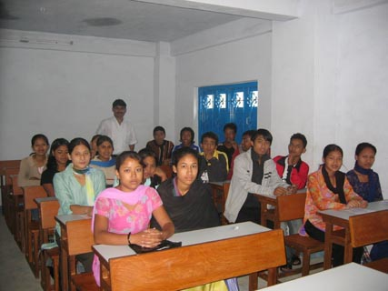
Handing over of the check The newly enrolled students of class 11
- The Rotaracts of Kathmandu Mid Town organized training sessions in the skill of Vision Testing for members of 9 Rotaract clubs on July 28th. The Sessions were conducted on 2 occasions by PP Rtn Dr Chandra Lekha Tuladhar at her clinic
- On July 30th The Rotaracts of Kathmandu Mid Town with the Rotarians and Rotaracts of Charumati conduct the first Vision screening for the "SIGHT" program at Ratna Rajya school / Baneswar - 181 children were screened of these 19 children require further assessment.
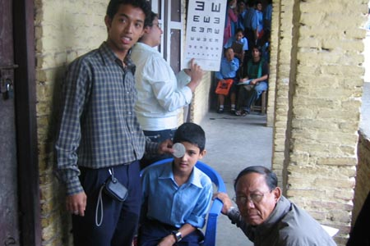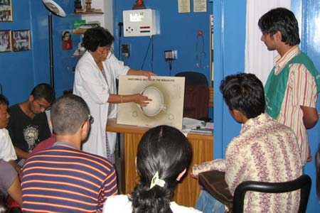
President Major Rai lends a helping hand Training sessions

THE ROTARY INTERNATIONAL ► NEWS
Project aids Iraqi land-mine victims
More than 50,000 Iraqi women and children have lost limbs to land mines, leaving them unable to work or attend school. Prosthetic limbs are very expensive in Iraq, and with hospitals frequently shutting down because of wartime conditions, prostheses — or even basic medical care — are difficult to find. In response, the Rotary Club of Montgomery Village, Maryland, USA, along with District 7620, created a Rotary centennial project in 2003 — the Basra Prosthetics Project — to help train Iraqi Ministry of Health physicians in Basra and raise money to provide necessary prosthetic limbs and equipment.
In 2006 after three years of fundraising, they were finally ready for their first training mission, but traveling to Basra was no longer safe. With the help of the Jordanian Embassy in Washington, D.C., the King Hussein Medical Center in Amman, Jordan, opened its doors to the project. Members of the Rotary Club of Amman Cosmopolitan also opened their homes to the project by hosting all the volunteers. In May 2006, eight Iraqi doctors and six people with amputations joined trainers and Rotarians in Jordan to learn how to correctly fit prostheses and get trained in prosthetic physiotherapy. The goal of this mission was to teach doctors to make more prostheses accurately and quickly to help more civilians.
To date, the Basra Prosthetics Project has received more than US$400,000 in donations from Rotarians and other project partners, including Al Hussein Society for the Habilitation/Rehabilitation of the Physically Challenged; the Jordanian Embassy in Washington, D.C.; Hanger Orthopedic Group; the International Monetary Fund; the Iraqi Ministry of Health in Baghdad; the Mosaic Foundation; Physicians for Peace; Security International; and the U.S. Department of State. The project still needs to raise money for training and supplies and to collect prosthetic devices.
By Lisa Baker Rotary International News 24 July 2007
Editor: Rabi Karmacharya, Club Service Director email: rabikarma@gmailcom

